You are to design the layout for the web page (given). You will need to:

* add structural elements to the web page;
* style the structural elements; and
* add style rules as necessary.

Here is what your webpage should look like:

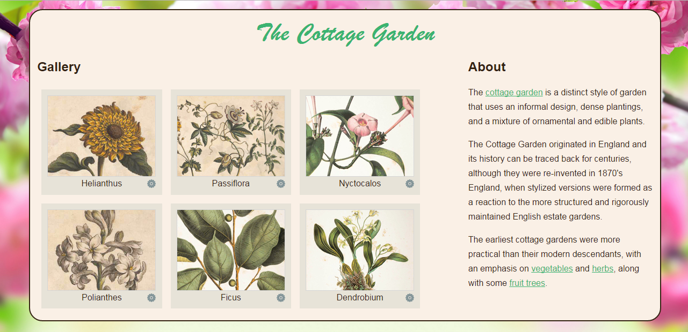

As you can see, there is a header. Underneath the header we have a section and beside the section we have an aside. As you can also see the body has a background image and the page content sits in its own division.

Your solution needs to display the following characteristics:

* The font family for the body is Helvetica, Arial or some sans-serif font. The text color for the body is #332211. The body has a background image (background.jpg) that has the background size set to ‘cover’.
* The page content is 85% wide and is centred. It has a 2px border, colour #332211, with rounded corners and a linen background colour.
* The h1 in the header section is Brush Script MT or some cursive font. The colour is medium sea green, size is 3em and the text is centered. The default margin is removed.
* The h2 headings are size 1.5em.
* The line height on the paragraphs is 1.7em.
* The section, that contains the gallery of images, has a width of 65% and is floated to the left.
* The aside, that contains the information on cottage gardens, has a width of 30%.
* The links are mediumseagreen in colour; the underline should disappear when the user hovers over a link; and the background colour is white when the link is active.
* The figures are floated to the left, and the background colour is #e7e3d8.
* The width of the images is 200px, and their height is 150px. The images have a border that is #d6d6d6 in colour.
* The figure captions have a background image (icon.png) and the caption text is centered.

Margin and Padding properties need to be added as required.